*Listed at*

*$300,000*

*Through ABC Mortgage*

*123 Main Street, Anytown, USA*

*This is a beautifully landscaped property*

*with majestic ceilings, new appliances*

*and stunning views. The house is in a*

*great location near shopping and schools.*

***Offered at the special price of $300,000***

John Loan Officer  
NMLS: XXXXXX  
ABC Mortgage Company

[john@loanofficer.com](mailto:john@loanofficer.com)  
555-555-5555

***Special Financing Provided By*…**

A person wearing a suit and tie smiling and looking at the camera

Description generated with very high confidence

*Features -*

* Two young years
* Four bedrooms, 3.5 baths
* Spacious master bedroom
* Finished basement
* Quiet cul-de-sac
* Upgraded appliances
* Beautiully landscaped





*FEATURED PROPERTY  
PRESENTS  
GORGEOUS SINGLE-FAMILY [CITY] HOME*

John Real Estate Agent

ABC Real Estate Company

[john@realtor.com](mailto:john@realtor.com)  
555-555-5555

***Listing Presented By…***

**A person wearing a suit and tie smiling and looking at the camera

Description generated with very high confidence**

For

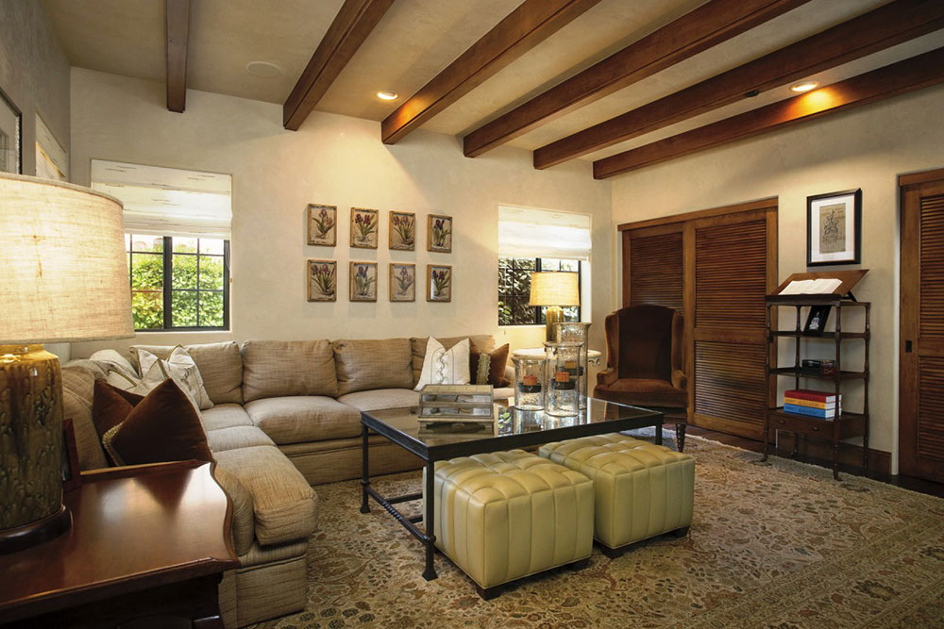

Included disclosure information here