2022 Purchase Mortgage Program Comparison Chart
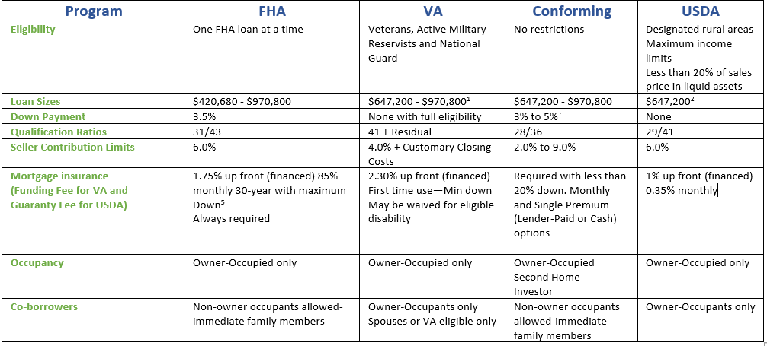
Notes: For educational purposes only. Not an offer to lend. Programs subject to availability and program requirements subject to change.
1. VA loan limits are for those with partial guarantee only. There are no loan limits for VA eligible borrowers with full guarantee available (subject to investor limits
2. USDA does not set loan limits for the program, but most investors set limit to the conforming loan limit.
3. For all programs, at a minimum -- citizenship, permanent resident status or valid work visa required.
4. Qualification ratios may be exceeded to as high as 45% to 50% under certain programs with strong compensating factors.
5. Monthly FHA Mortgage Insurance .85% up to $625,000 and 1.05% greater than $625,000.
6. Freddie Mac Home Possible TM and Fannie Mae HomeReady TM are special conforming 3.0% down programs. These programs may contain additional restrictions such as income limits and first-time homebuyer status and require 5.0% down over the base conforming limit. The programs may offer lower mortgage insurance payments and reduced cash obligations through community seconds where available. Homebuyer education may be required.
7. State Bond Programs may feature FHA, VA., Rural Housing and Conforming loans. These loans may be available at lower than market rates, may offer closing cost and/or down payment assistance and reduced mortgage insurance for conforming loans. Must be a first-time buyer with maximum income limits, which may be waived in targeted areas.

5.

Photo/logo
LO Name
Title, NMLS ID: #xxxxxx
555 X Street
Main, VA 22222
Office: (xxx) xxx-xxxx | Mobile: (xxx) xxx-xxxx
email@hershmangroup.com
www.website.com

For educational purposes only. Not for consumer distribution. Program guidelines subject to change.

©January 2022 OriginationPro

